Gambia, The

## Freedom House political status

The data set shows the Freedom House political scores and status of the country each year.

## # A tibble: 19 x 5  
## country iso3c date mean status   
## <chr> <chr> <dbl> <dbl> <chr>   
## 1 Gambia, The GMB 1996 6.5 Not Free   
## 2 Gambia, The GMB 1998 6 Not Free   
## 3 Gambia, The GMB 2000 6 Not Free   
## 4 Gambia, The GMB 2002 4 Partly Free  
## 5 Gambia, The GMB 2003 4 Partly Free  
## 6 Gambia, The GMB 2004 4 Partly Free  
## 7 Gambia, The GMB 2005 4.5 Partly Free  
## 8 Gambia, The GMB 2006 4.5 Partly Free  
## 9 Gambia, The GMB 2007 4.5 Partly Free  
## 10 Gambia, The GMB 2008 4.5 Partly Free  
## 11 Gambia, The GMB 2009 5 Partly Free  
## 12 Gambia, The GMB 2010 5 Partly Free  
## 13 Gambia, The GMB 2011 5.5 Not Free   
## 14 Gambia, The GMB 2012 6 Not Free   
## 15 Gambia, The GMB 2013 6 Not Free   
## 16 Gambia, The GMB 2014 6 Not Free   
## 17 Gambia, The GMB 2015 6.5 Not Free   
## 18 Gambia, The GMB 2016 6 Not Free   
## 19 Gambia, The GMB 2017 4.5 Partly Free

## Freedom House classification of political change

The data set shows the GDP growth and the ecomic growth classification of the country each year.

## # A tibble: 19 x 4  
## country iso3c date politicalChangeFH  
## <chr> <chr> <dbl> <chr>   
## 1 Gambia, The GMB 1996 no change   
## 2 Gambia, The GMB 1998 democratization   
## 3 Gambia, The GMB 2000 no change   
## 4 Gambia, The GMB 2002 democratization   
## 5 Gambia, The GMB 2003 no change   
## 6 Gambia, The GMB 2004 no change   
## 7 Gambia, The GMB 2005 autocratization   
## 8 Gambia, The GMB 2006 no change   
## 9 Gambia, The GMB 2007 no change   
## 10 Gambia, The GMB 2008 no change   
## 11 Gambia, The GMB 2009 autocratization   
## 12 Gambia, The GMB 2010 no change   
## 13 Gambia, The GMB 2011 autocratization   
## 14 Gambia, The GMB 2012 autocratization   
## 15 Gambia, The GMB 2013 no change   
## 16 Gambia, The GMB 2014 no change   
## 17 Gambia, The GMB 2015 autocratization   
## 18 Gambia, The GMB 2016 democratization   
## 19 Gambia, The GMB 2017 democratization

## Freedom House score trend

The plot shows the Freedom House scores trend of the country.

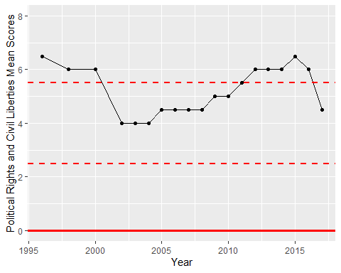

Freedom House Score Trend